NATIONAL UNIVERSITY OF MODERN LANGUAGE ISLAMABAD
Lab 04


Submitted to:
Sir Hassan Shah
Submitted by:
Zulqarnain Hassan
Roll No: …………………… SP21379
Subject: …………………… computer network
Department: ……………… BSSE-5-Afternoon
Date: ……………………… 10-11-2024

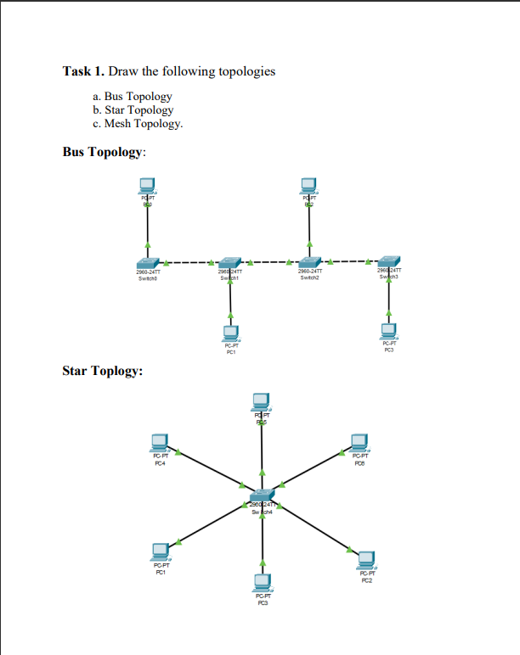

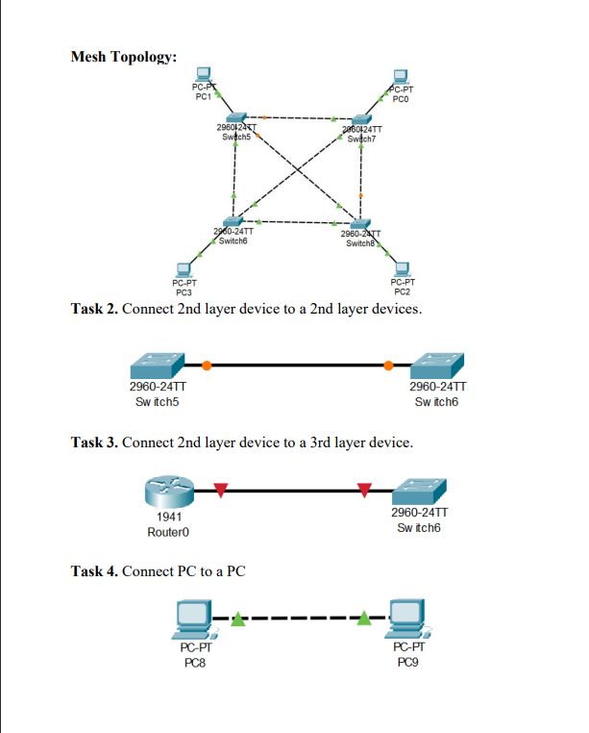

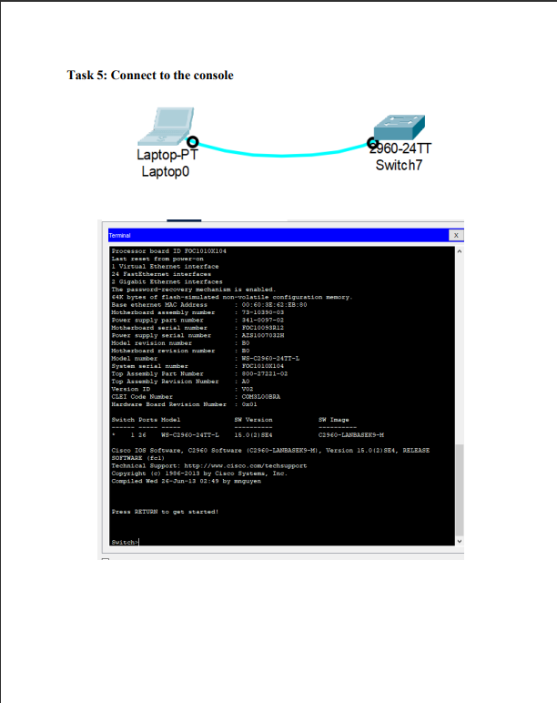
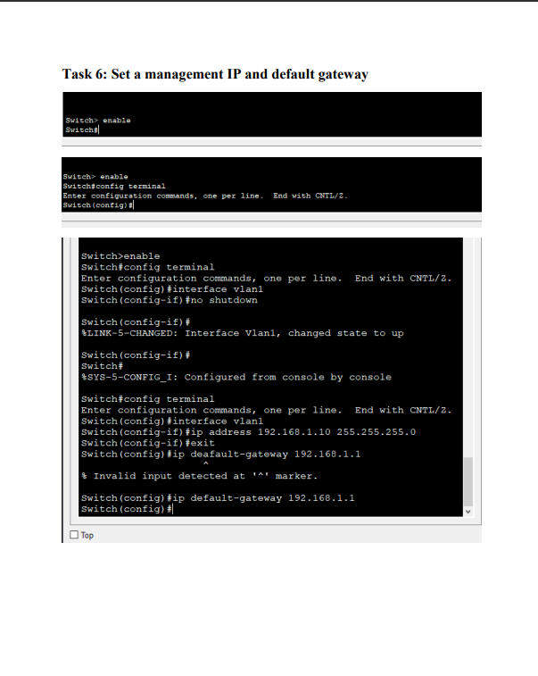

Task 7: Set hostname
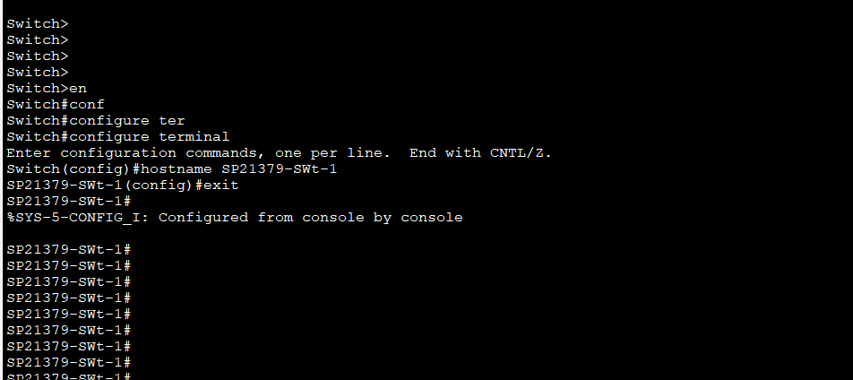
Task 8: Setting Duplex of Individual Port
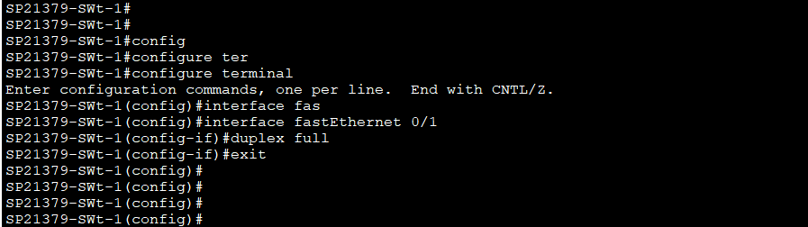
Task 9: Setting speed of individual port and setting up the mode
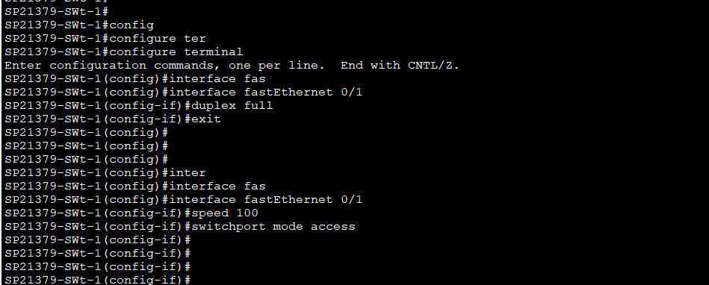

Task 10: For multiple ports assignment (only for Switch)
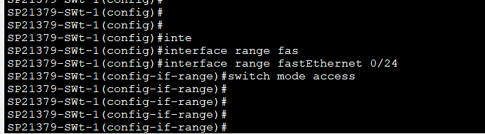

Task 11: Save Configuration
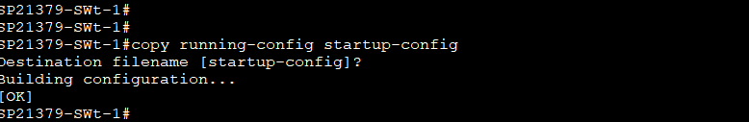
Task 12: Switch(config)#no ip domain lookup Router(config)#no ip domain lookup
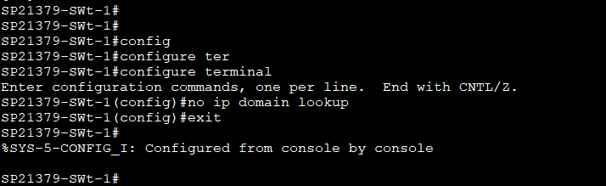
Task 13: Switch(config)#line con 0 Switch(config-line)#logging synchronous Router(config)#line con 0 Router(config-line)#logging synchronous
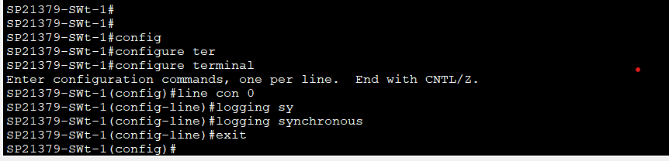

Task 14: Show running-config
